MYSQL

1- MY SQL SERVER, WORKBENCH & SHEEL INSTALLAITON PROCESS ON WINDOW 11🡪

Google 🡪 Mysql 🡪 official website (https://www.mysql.com/)🡪 https://www.mysql.com/downloads/ 🡪 [MySQL Community (GPL) Downloads](https://dev.mysql.com/downloads/) 🡪 [MySQL Installer for Windows](https://dev.mysql.com/downloads/windows/) 🡪 download 296mb 🡪 No thanks just download

After installing the sql download file 🡪 INSTALL 🡪 below screen you will appear after install

**After you execute all the steps & execute finally SQL WORKBENCH & SQL command line interpreter will open.**

**Create password only simple digit & don’t create password with ascii characters.**

To access mysql in your command line prompt follow the below steps 🡪

* C:\Program Files\MySQL\MySQL Server 8.0\bin
* Copy the above path and paste in system environment variable under
* Do not click on user variables Click on system variable 🡪 path 🡪 new 🡪 paste

* Mysql prompt is created 🡪 type exit to route to original prompt

**HOW TO START WORK WITH WORKBENCH 🡪**

SQL Workbench is a powerful tool designed for working with databases. It provides an interface to manage and interact with SQL databases.

Key uses of the workbench 🡪 Database Management || Query Execution || Data visualization || SQL Development || Database Connectivity || Data import & export || Schema Browing || user management

open workbench 🡪

* show databases; ( display list of databases) || lower case & upper case both allow
* user can also execute the query using command line as well.
* Upcoming query we will use command line for better understanding.





Workbench user can create db in 2 ways 🡪

* Click on 4th icon 🡪 create new schema in server 🡪 write db name 🡪 apply
* Other way - create database nit_db;

Create database in command line 🡪 create database store_db;

* To clear the output in command use (system cls)



* Cmd 🡪 use school_db; (now user enter to school_db & all the work will be done inside the school_db)
* select database(); 🡪 display current database information





* drop database store_db;

Varchar(100) -- variable length upto 100 characters

Work bench 🡪

* use test_db; I want to create table in test_db
* CREATE TABLE customers(

Id INT,

name VARCHAR(100)

); 🡺 refresh ( customers table is created under test_db)

Using command prompt also we can create table under by writing below query 🡪

USE nit_db;

CREATE TABLE students(id INT, name VARCHAR(50),city VARCHAR(50));

Other way also you can assign the above 1 line to multiple line as well.

CREATE TABLE students(

🡪 id INT,

🡪 name VARCHAR(50),

🡪 city VARCHAR(50)

);





* Cmd 🡪 DESC students; || DESC student1; ( DESC meaning describe table)
* Also we can verify these tables in work bench also



* Using work bench you can add data into table by using below query 🡪

INSERT INTO students(id, name, class)

VALUES

(101, "MAX", 5);

Using command line prompt also you can execute below code 🡪

INSERT INTO students VALUES(102, "ANA", 8);





Work bench 🡪 SELECT * FROM students;

If we need detail of only 103 row then 🡪 SELECT * FROM students WHERE id = 103;



If refresh in workbench as well table is drop from the database

Cmd 🡪 show tables; 🡪 DESC students;

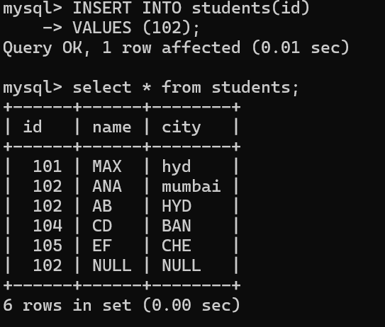

If you check above code last id 102 we got 2 null because by default it consider null value

We added all null values in above cmd prompt & to avoid these null values we will use NOT NULL

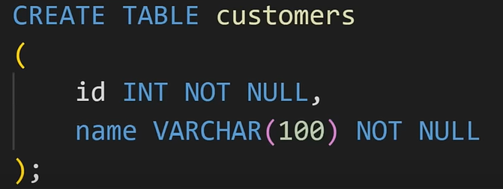

To remove null values need to write below script

In below cmd 2 table created students table has null values & student1 has no null values

Created new table under student1; and error as name doesn’t have default value



Even though user enter null values still cannot possible cuz we create this table by using not null

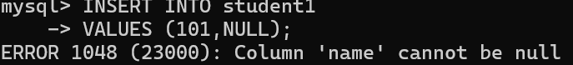

user want to create employee table you have to use default values

We want to add data in table



LIST ALL EXISTING DATABASES

LIST ALL EXISTING DATABASES

LIST ALL EXISTING DATABASES